Johnny’s Fitness Challenge

***Month 1***

|  |  |  |  |  |  |  |
| --- | --- | --- | --- | --- | --- | --- |
| 1 | 2 | 3 | 4 | 5 | 6 | 7 |
| 8 | 9 | 10 | 11 | 12 | 13 | 14 |
| 15 | 16 | 17 | 18 | 19 | 20 | 21 |
| 22 | 23 | 24 | 25 | 26 | 27 | 28 |
| 29 | 30 |  |  |  |  |  |

***Month 2***

|  |  |  |  |  |  |  |
| --- | --- | --- | --- | --- | --- | --- |
| 1 | 2 | 3 | 4 | 5 | 6 | 7 |
| 8 | 9 | 10 | 11 | 12 | 13 | 14 |
| 15 | 16 | 17 | 18 | 19 | 20 | 21 |
| 22 | 23 | 24 | 25 | 26 | 27 | 28 |
| 29 | 30 | 31 |  |  |  |  |

***Month 3***

|  |  |  |  |  |  |  |
| --- | --- | --- | --- | --- | --- | --- |
| 1 | 2 | 3 | 4 | 5 | 6 | 7 |
| 8 | 9 | 10 | 11 | 12 | 13 | 14 |
| 15 | 16 | 17 | 18 | 19 | 20 | 21 |
| 22 | 23 | 24 | 25 | 26 | 27 | 28 |
| 29 | 30 |  |  |  |  |  |

Exercises

Workout 1: (Red)

* Each exercise is done for as many reps as possible in 1 minute.
* 5 minutes per round
* Repeat for 3 rounds
* Total time is 15 minutes.

**Warm-up**: 30 seconds of star jumps

30 seconds rest

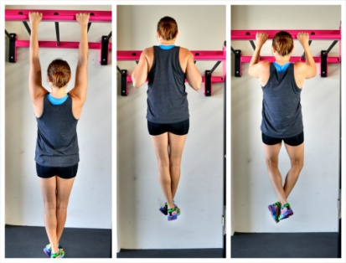 30 seconds of star jumps

1. **Pull-up**

( overhand grip, just wider than shoulder-width )

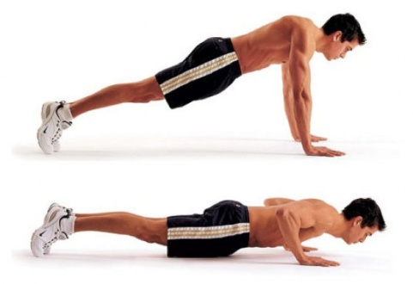

1. **Push-up**

( hands shoulder-width apart )

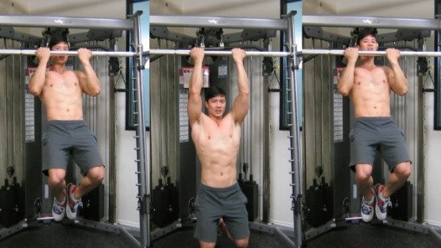

1. **Chin-up**

( underhand grip, shoulder-width apart )

1. 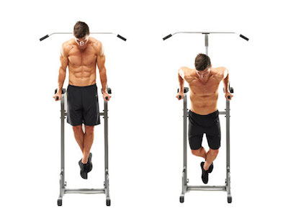**Bar Dips** or **Diamond Push-ups**

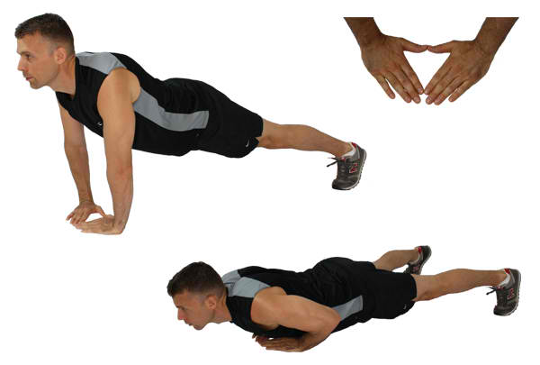

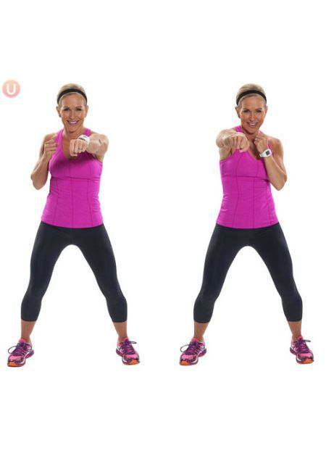

1. 1 minute of **Shadow Boxing**

Workout 2: (Yellow)

* Each exercise should be done in 1 minute
* 4 exercises for 4 minutes per round
* Repeat for 3 rounds
* Total time is 12 minutes.

**Warm-up**: Run 30 seconds or 1 minute of Jumping Jacks

Rest 30 seconds

Run 30 seconds

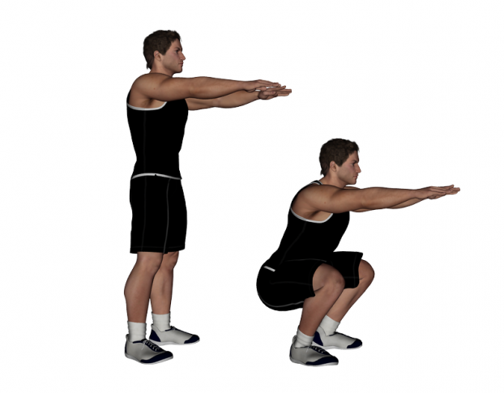 Sprint 30 seconds

1. **Squat**

(15 repetitions in 1 minute)

1. **Lunges**

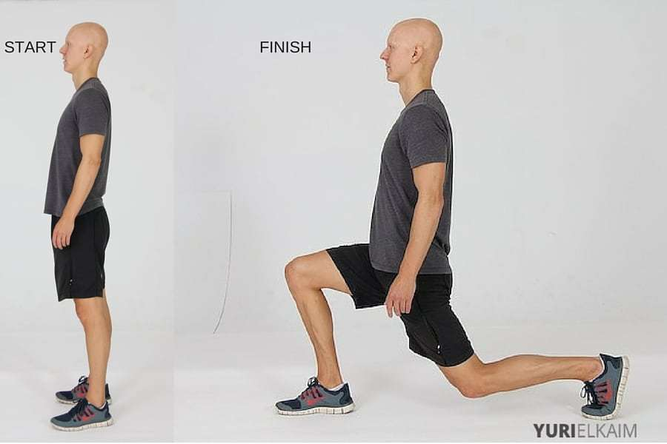

(14 repetitions in 1 minute – 7 each side )

1. 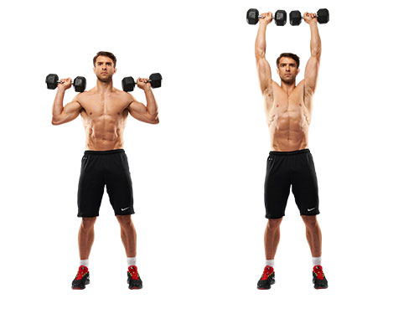**Overhead Press with Weights**

(15 repetitions in 1 minute)

1. 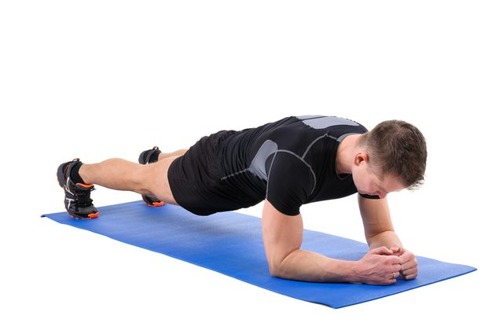**Plank**

(20 second hold, rest 20 seconds, 20 second hold)